_{Mid-term Take-home Exam}
_{Due March 16 2023}
_{Each question worth 25 pts}
In class I related an experience related to converting 60Hz AC power to other desired frequencies by strategically switching current on and off. A similar technique is used in dimmer switches. The circuit below is the approached used. By the way, the circuit is totally background and does not play a role in this exam.
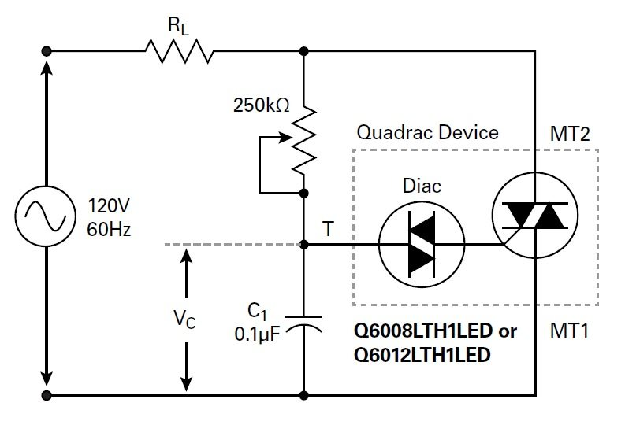
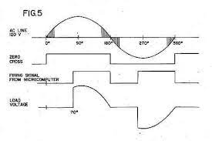
Using the voltage signal shown in the figure above, answer the following questions. Please show all work and submit answers using Matlab live script files. Be sure to label plots appropriately.

- .For the voltage signal, model the signal using a Fourier series. Include at least the first 10 terms of the series Keep in mind this is a voltage at 60 Hz with the rms amplitude of 120 volts
- Sample the signal at 20 samples per cycle and calculate the appropriate the discrete components. Plot the Re and Im components. Be sure they are scaled correctly.
- Sum the components of the DFT and the Fourier series to recreate the signal, overlay these plots to compare to the continuous signal. Briefly discuss the differences you observe.
- Given the data file, LS data, fit a second order equation to the data, Perform an FFT on the residuals. Is there deterministic content in residuals? What are they?

